|  |  |
| --- | --- |
|  | FPT ACADEMY INTERNATIONAL  FPT – APTECH COMPUTER EDUCATION |

Centre Name: ACE-HCMC-2-FPT.

Address: 590 Cach Mang Thang 8, District 3, Ho Chi Minh City, Viet Nam.

**[GLASSES STORE]**

|  |  |  |
| --- | --- | --- |
| Supervisor: | Phạm Thị Lánh | |
| Term: | 1 | |
| Batch No: | T2212E1 | |
| Group No: | 2 | |
| Order: | Full name | Roll No. |
| 1. | NGO GIA TU BINH | Student1438980 |
| 2. | NGO TAN PHUC | Student 1441819 |
| 3. | NGUYEN PHUC NGUYEN CHUONG | Student1438978 |
| 4. | CHAU GIA BAO | Student 1438985 |

Month 04 Year 2023

This is to certify that

**Mr. NGO GIA TU BINH**

**Mr. NGO TAN PHUC**

**Ms. CHAU GIA BAO**

**Mr. NGUYEN PHUC NGUYEN CHUONG**

Have successfully Designed & Developed

**GLASSES STORE**

Submitted by: **Ms. PHAM THI LANH**

Date Of Issue: April, 2023

# 

# Content

Content 3

Acknowledge 5

Synopsis 5

REVIEW 1 6

Problem Definition 6

Customer Requirements Specifications 7

Architecture and Design of the project 8

Site map 8

Website Design Layout 9

I. Homepage 9

II. Sign in 11

III. Sign up 12

IV. Product Category/Search Page 12

V. Product Detail 13

VI. Cart Dropdown 14

VII. Check out 14

VIII. Contact 15

IX. About 15

Task Sheet 16

REVIEW 2 17

WEBSITE USER INTERFACE 18

I. Homepage 18

II. Sign in 21

III. Sign up 21

IV. Product Category/Search Page 22

V. Product Comparison 24

VI. Product Detail 25

VII. Cart Dropdown 26

VIII. Check out 26

IX. Contact 27

X. About 28

Task Sheet 29

Testing document 30

Final checklist 31

# Acknowledge

We appreciate that eProject provides a learning platform that mimics classroom and lab-based environments. It allows us to practice step by step and develop more robust applications. We learned how to implement concepts in a phased manner, enhance skills, work on real-life projects, and receive mentoring through email support. We extend our gratitude to our professor and fellow students for their support during the project. Despite some mistakes, we look forward to more opportunities to expand our knowledge in web development.

Thank you for providing us with valuable information and the "demo" project from India APTECH, which gave us a more realistic experience. We will continue to learn and strive for success in the future.

Sincerely,

Team Group 02.

# Synopsis

* The objective of this program is to provide a sample project for real-life application development.
* The focus is not on teaching HTML/JavaScript but on creating basic applications using these tools in a real-life scenario.
* Students should review relevant topics before starting the project.
* This project is intended for students who have completed the HTML5 module and should be completed in the Lab sessions with faculty assistance if needed.
* The website created in this project serves as a tool for the company to expand into international markets and gain new customers.
* It is essential for students to have a clear understanding of the subject matter.

# REVIEW 1

## Problem Definition

GlassesStore has a store for glasses. They want to expand their business online and create a website to showcase their products. The website should be easy for consumers to navigate and find the right product to meet their needs.

A website needs to be designed to display various glasses available with the store. Details of locations using GeoLocation API (eg. GoogleMaps), feedback must be included.

The website is to be developed for the Windows Platform using HTML5, JavaScript and Geolocation. The site should work well in all leading browsers including Chrome, IE, Firefox etc.

Here are some problems need to be resolved:

1. With the changing environment, more and more customers are interested in shopping online and this issue leads to the situation that customers want to find information about various products easily on the Glasses Store website and purchase the right product that meets their needs.
2. Many customers are unfamiliar with the product range, leading to mismatches between their expectations and delivered products, resulting in wastage of time, resources, and delivery costs.
3. Online customers have a preference for reading reviews before purchasing specific products.
4. Existing customers requiring help and support on products after installation should have easy access to contact Glasses Store through phone or email. Additionally, some customers may prefer to visit the physical store to view products before making a purchase decision.

## Customer Requirements Specifications

|  |
| --- |
| USER: |
| Input:  ● Input consumer’s address of residence or office  ● Send questions/requests to the company |
| Process:  ● Process consumer’s address data  ● Collect questions/requests sent by consumers |
| Output:  ● Show the store address to consumers  ● Reply to the consumer’s requests/questions |

|  |
| --- |
| WEBMASTER: |
| Input:  ● Control website database, input product information,… |
| Process:  ● Analyse website |
| Output:  ● Website interface, images, forms, …  ● Giving interaction |

|  |
| --- |
| HARDWARE / SOFTWARE REQUIREMENT: |
| Software:  ● HTML editor  ● Javascript |
| Hardware:  ● A minimum computer system that will help you access all the tools in the courses is a Pentium 166 or better  ● 64 Megabytes of RAM or better |

## Architecture and Design of the project



## Site map

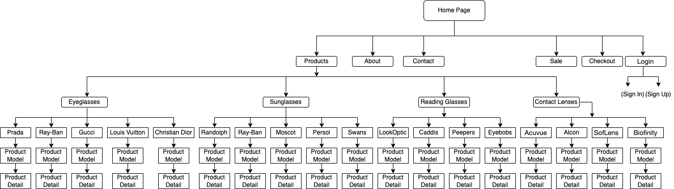

## Website Design Layout

### Homepage

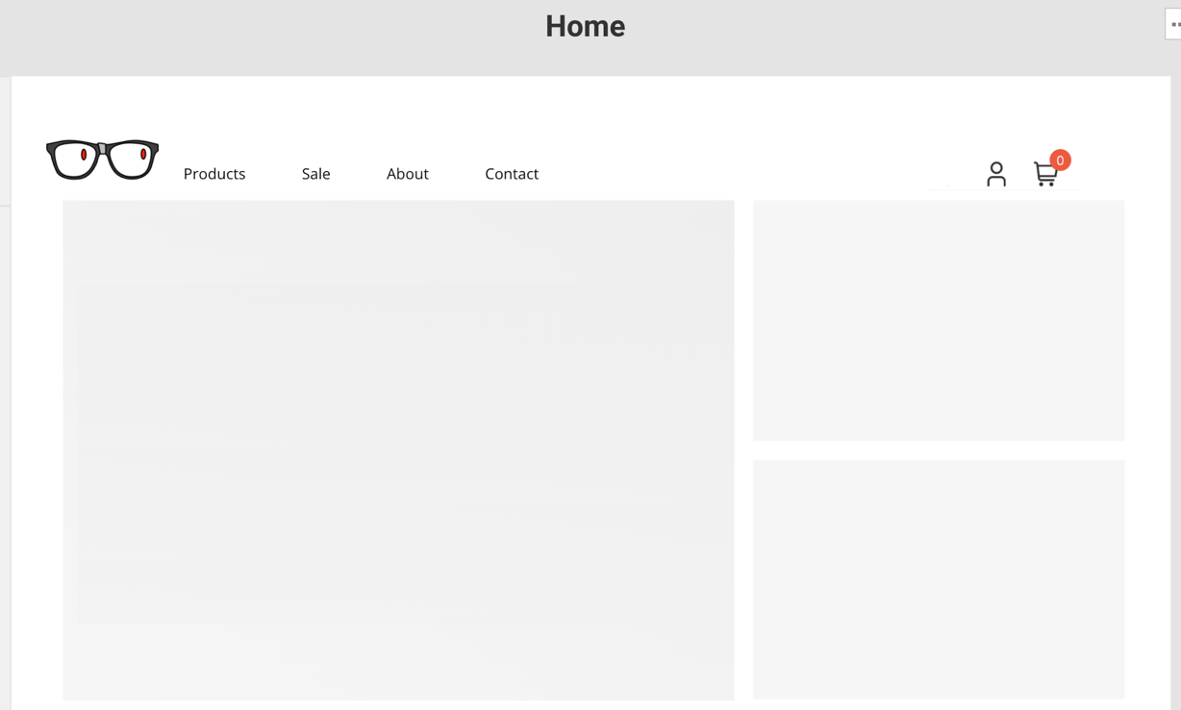

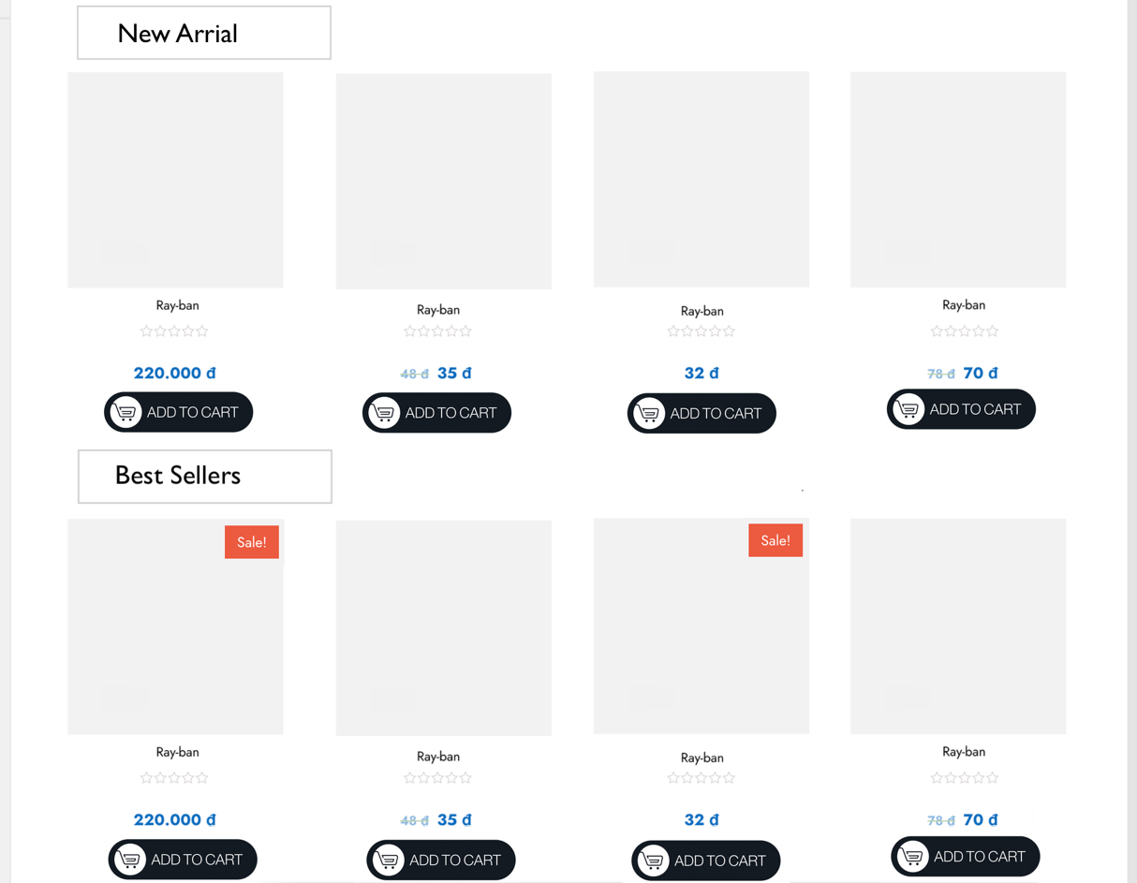

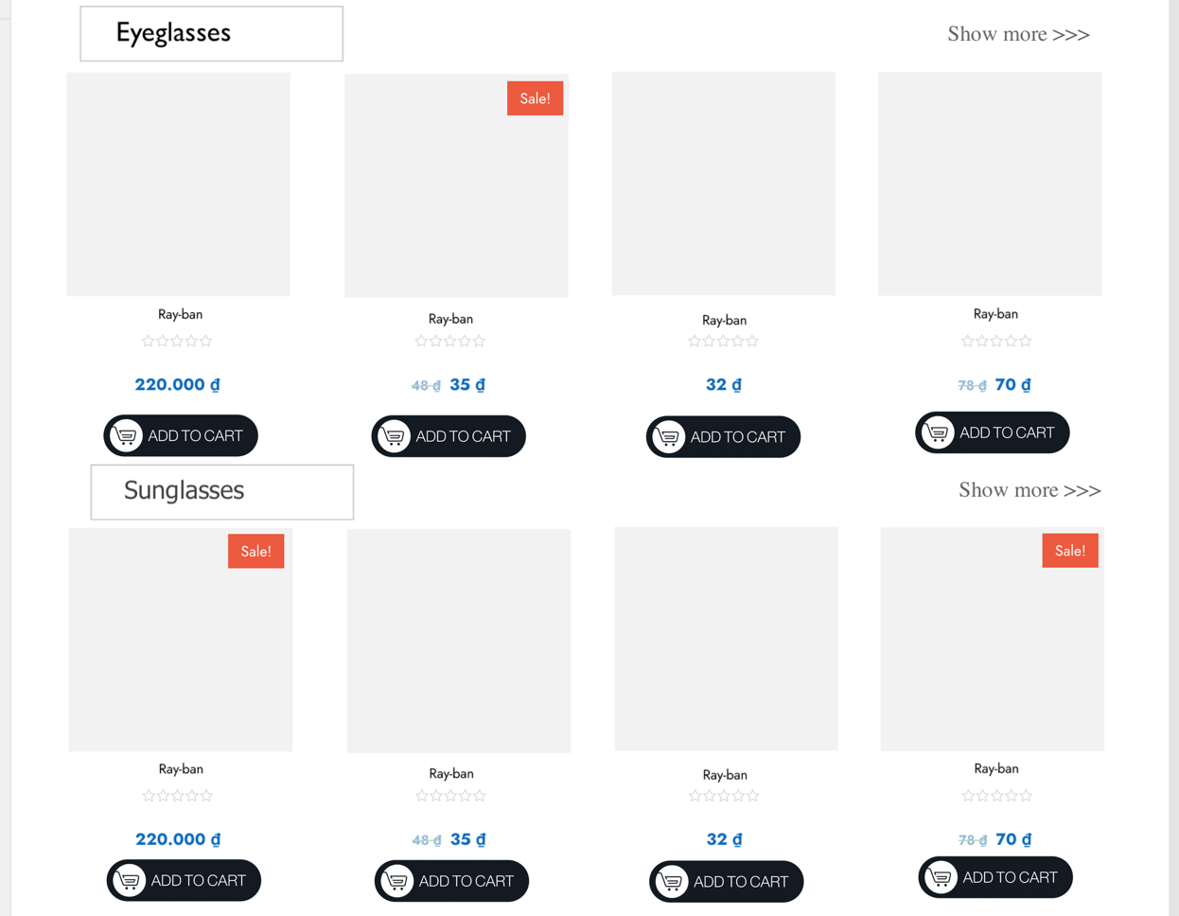

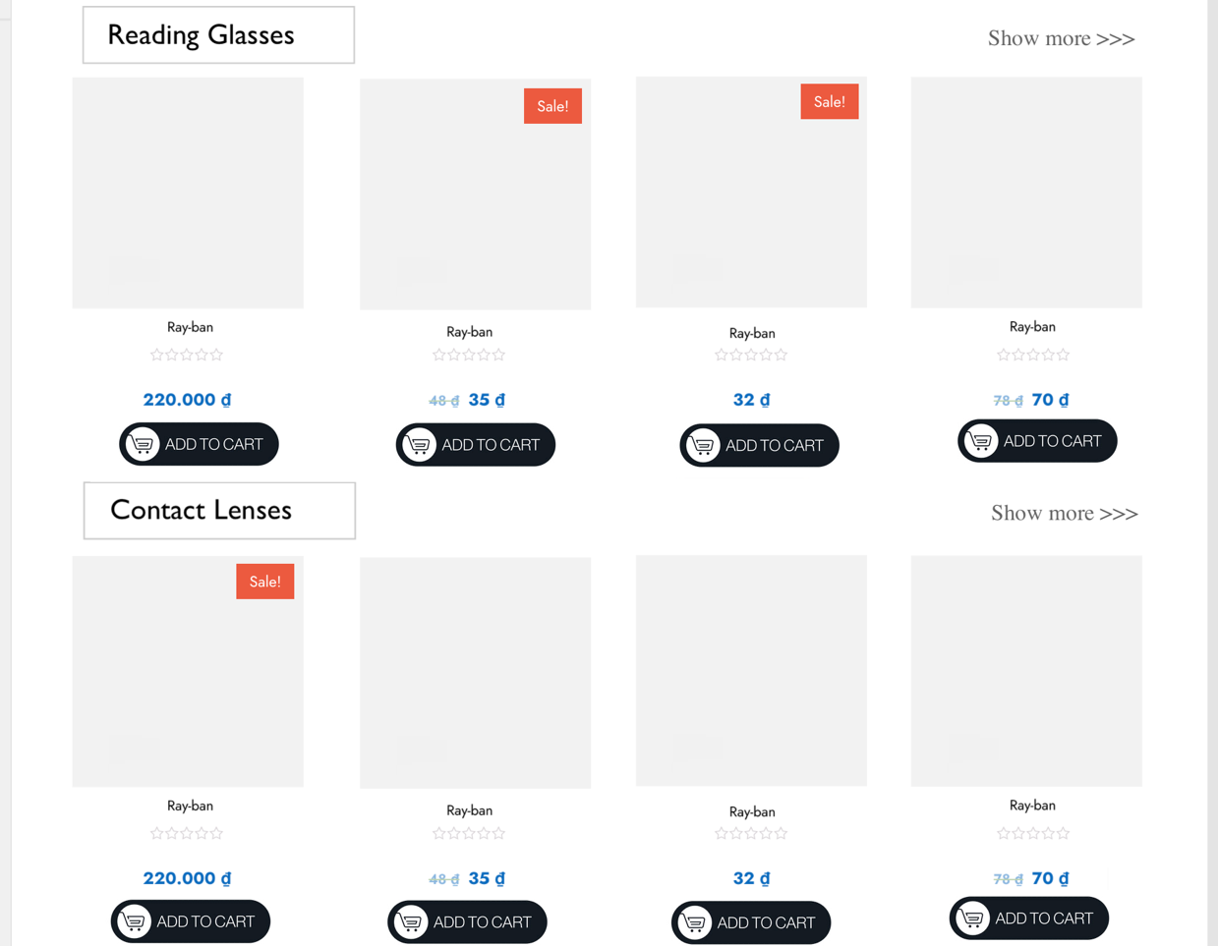

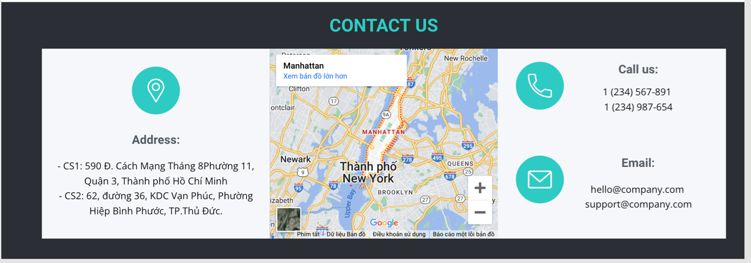

**Description:** This is a homepage of Glasses Store, the top of this page is a header, after that is a navigation bar. The main part of a homepage beside the slider also includes 4 sections: new arrial, best sellers and four glasses types (Eyeglasses, Sunglasses, Reading Glasses, Contact Lenses). The footer of a homepage has 3 sections: Address, map and contact information.

### Sign in

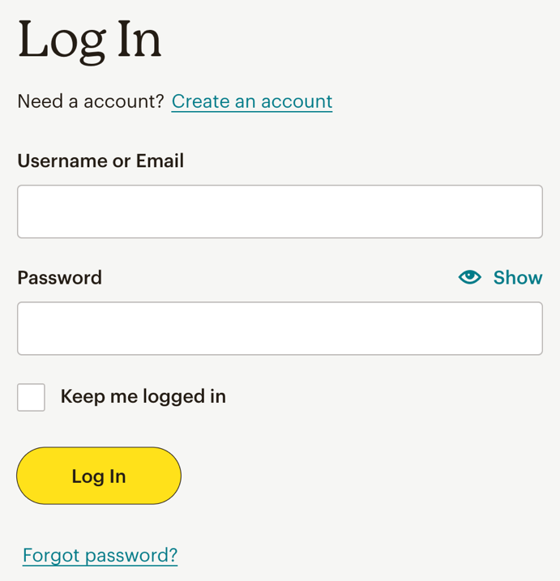

**Description:** When the user clicks on the human icon in the header, it leads to a sign in page. This form requires the user to enter an email address and a password. After clicking the login button, the user will be redirected to the homepage.

### Sign up

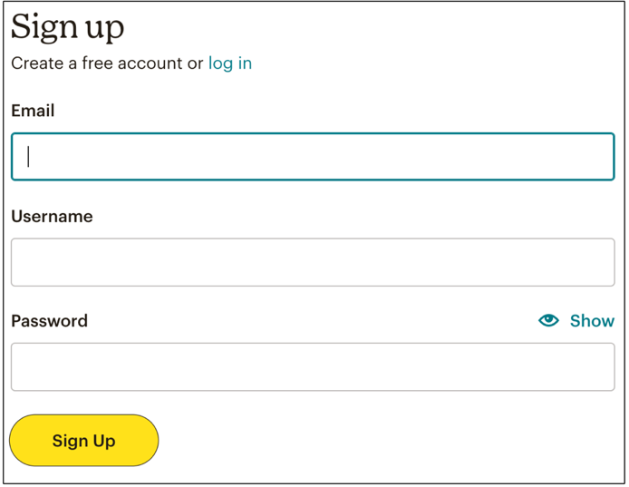

**Description:** If the user hasn’t created an account, he/she can click to Create new account in the sign in page and it will lead to this sign up page. This sign up form requires the user to enter 3 fields: email, username and password. After clicking the sign up button the user will be redirected to the homepage.

### Product Category/Search Page

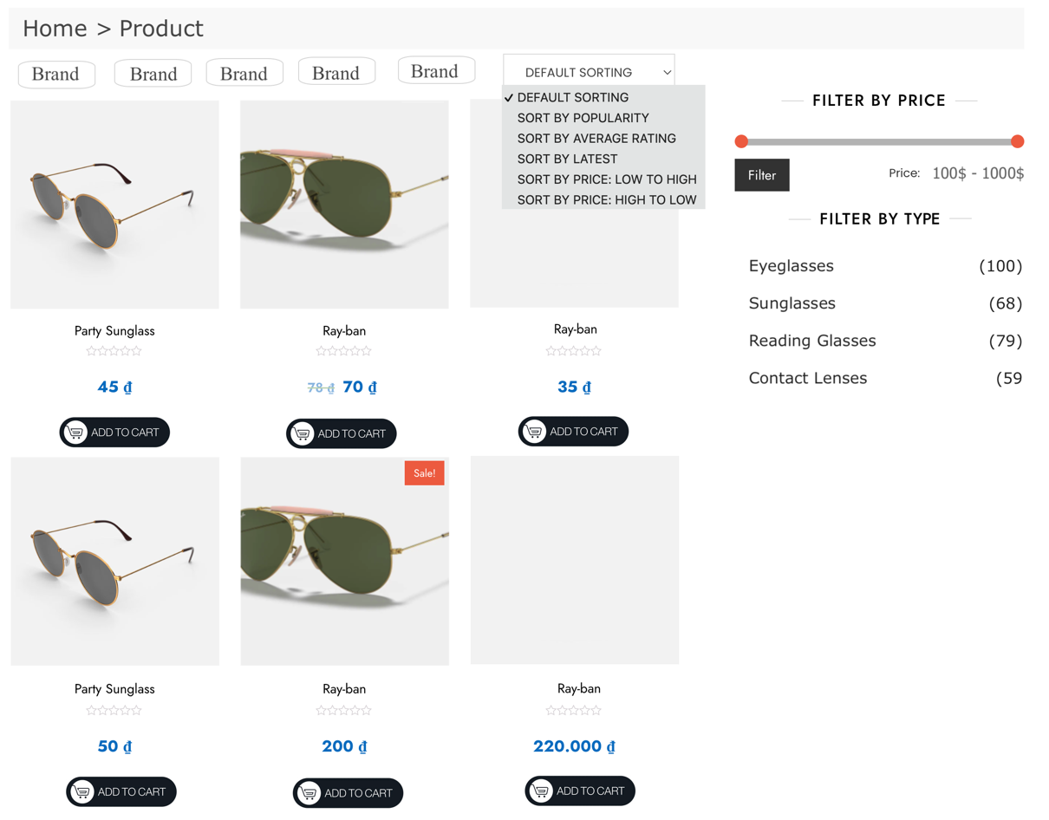

**Description:** When the user clicks on a specific category in the sub menu of the Products tag on navigation, it will lead to this page. The left part is a filter which contains filters by: glasses types, brands, rating and price. The right part is a result of a specific product.

### Product Detail

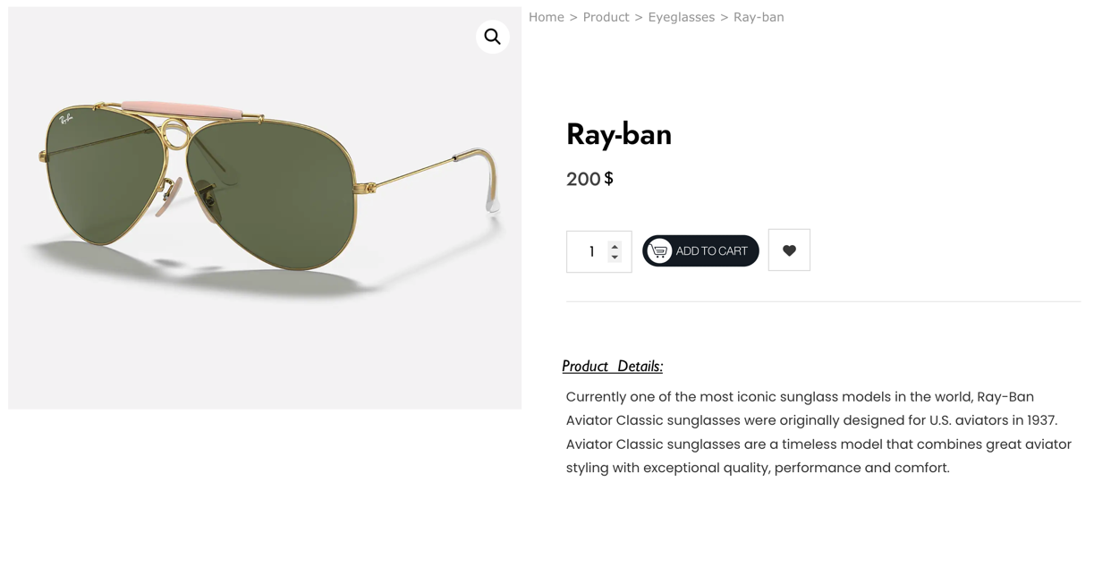

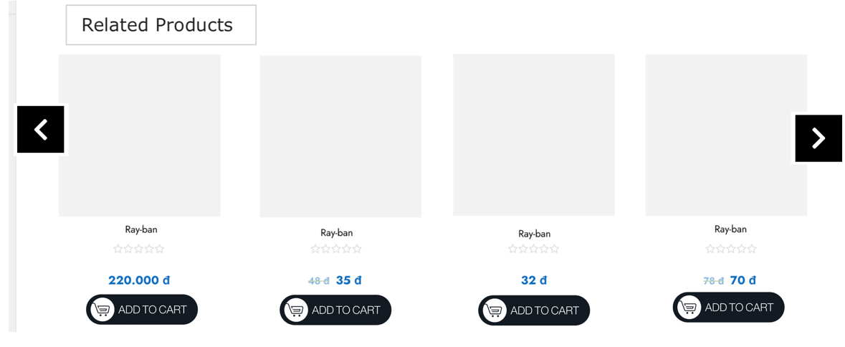

**Description:** When the user clicks on a specific product it will lead to this product detail page. Beside in detail information about the product, it also contains Call to Action buttons Buy now. The last part of this page is the Related Products section.

### Cart Dropdown

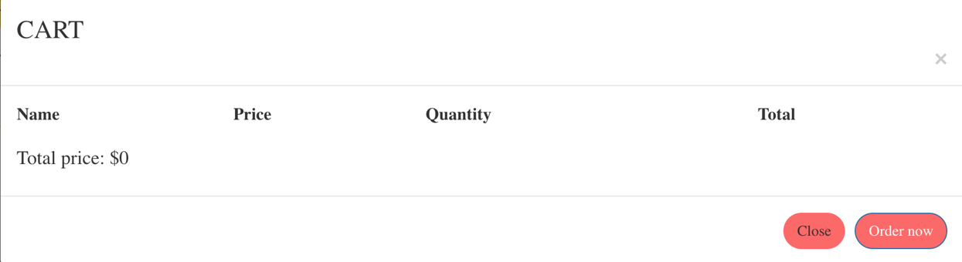

**Description:** When the user clicks on the cart icon in the header, the cart information will appear. It includes products that users have already added to cart, the user can select all items or remove items which they don’t have the intention to buy.

### Check out

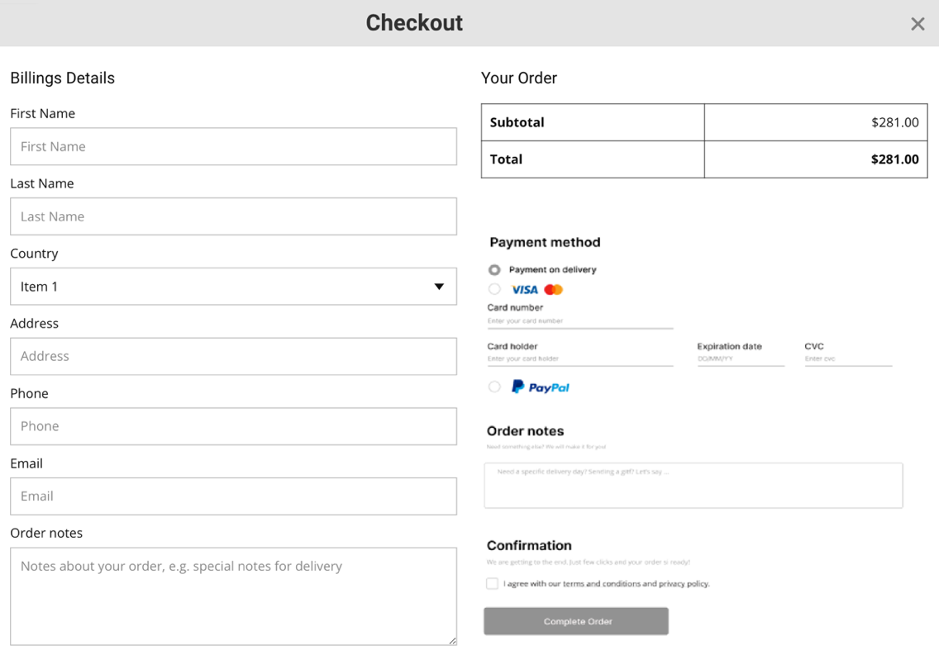

**Description:** After clicking the Check out button on the Cart or Buy now button in Product Detail Page, the user will be redirected to this checkout page. The left part of this page contains a form which requires the user to enter and the other side is the Order summary.

### Contact

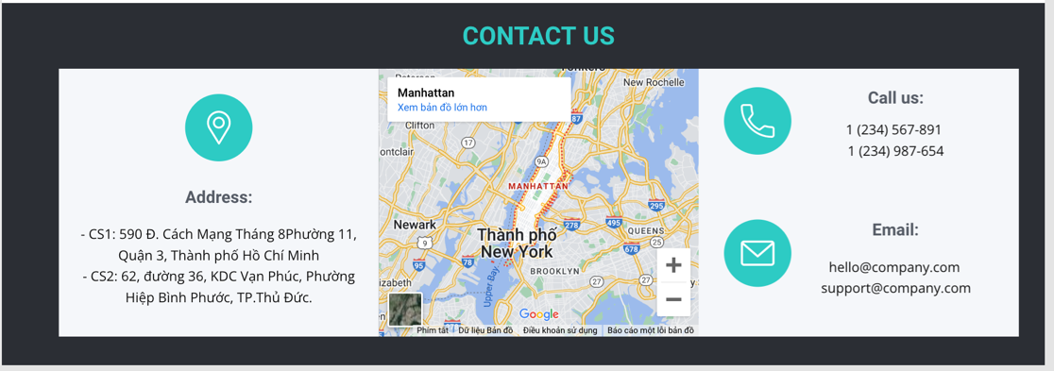

**Description:** After clicking the Contact tag on the navigation bar, the user will be redirected to this page. The first part of this page is a map, beside it is a detailed location of Glasses Store’s Branches. The last part of this page is a Send information form to send their information to Glasses Store.

### About

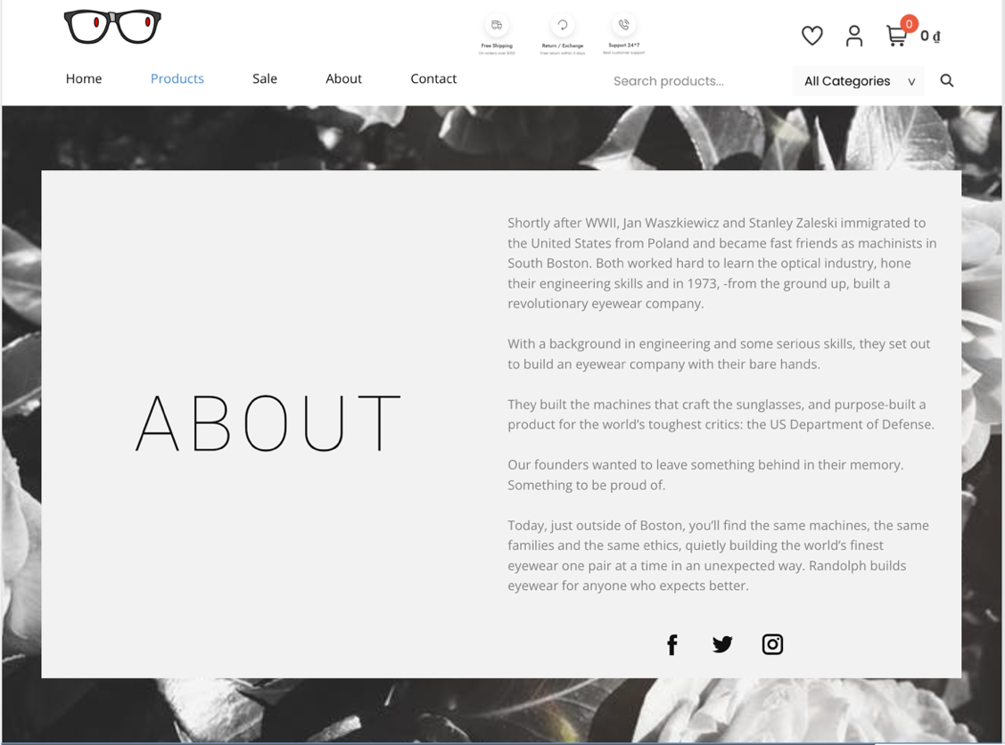

**Description:** After the user clicks on the About tag on the navigation bar, it will lead to this about page. This page contains detailed information about Glasses Store.

## Task Sheet

|  |  |  |  |  |  |  |
| --- | --- | --- | --- | --- | --- | --- |
| **Project Ref No.** | **Project Title – Ask Me Mobile** | **Activity Plan Prepared by** | **Date of preparation of Activity Plan** | | | |
| **Task** | **Actual Start Date** | **Actual Days** | **Teammate Names** | **Status** |
| Brainstorming ideas for layouts and Project Object | | Binh, Phuc, Bao,  Chuong | 11/03/2023 | 1 days | Binh, Phuc, Bao, Chuong | Completed |
| Draw site maps and architecture design | | Binh, Phuc, Bao,  Chuong | 14/03/2023 | 1 days | Binh, Phuc, Bao, Chuong | Completed |
| Wire framing general page layout | | Binh | 16/03/2023 | 3 days | Binh | Completed |
| Collect static assets (pictures, documentation,…) | | Phuc, Bao,  Chuong | 16/03/2023 | 5 days | Phuc, Bao,  Chuong | Completed |

# REVIEW 2

# WEBSITE USER INTERFACE

### Homepage

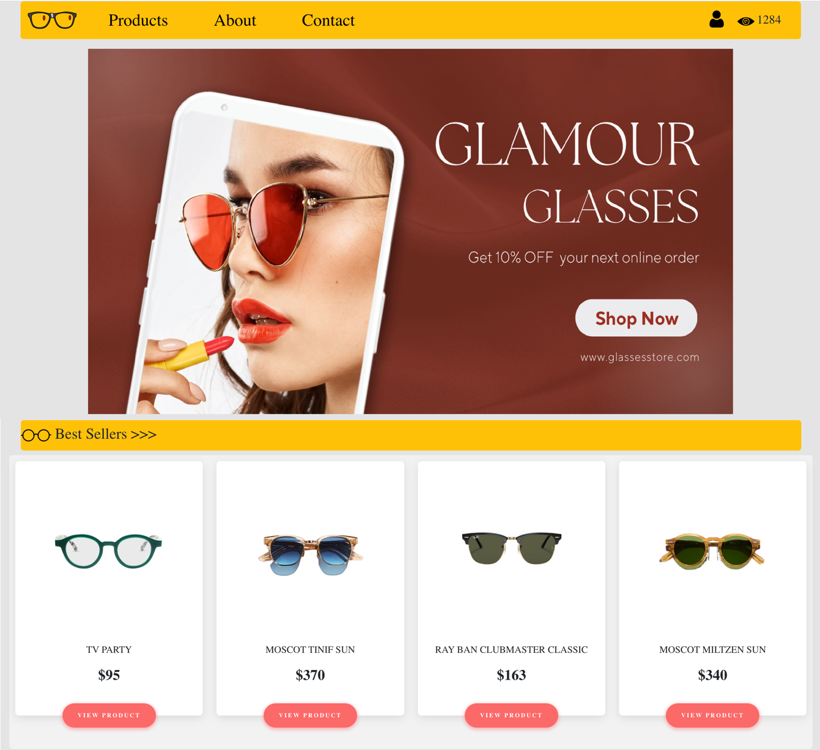

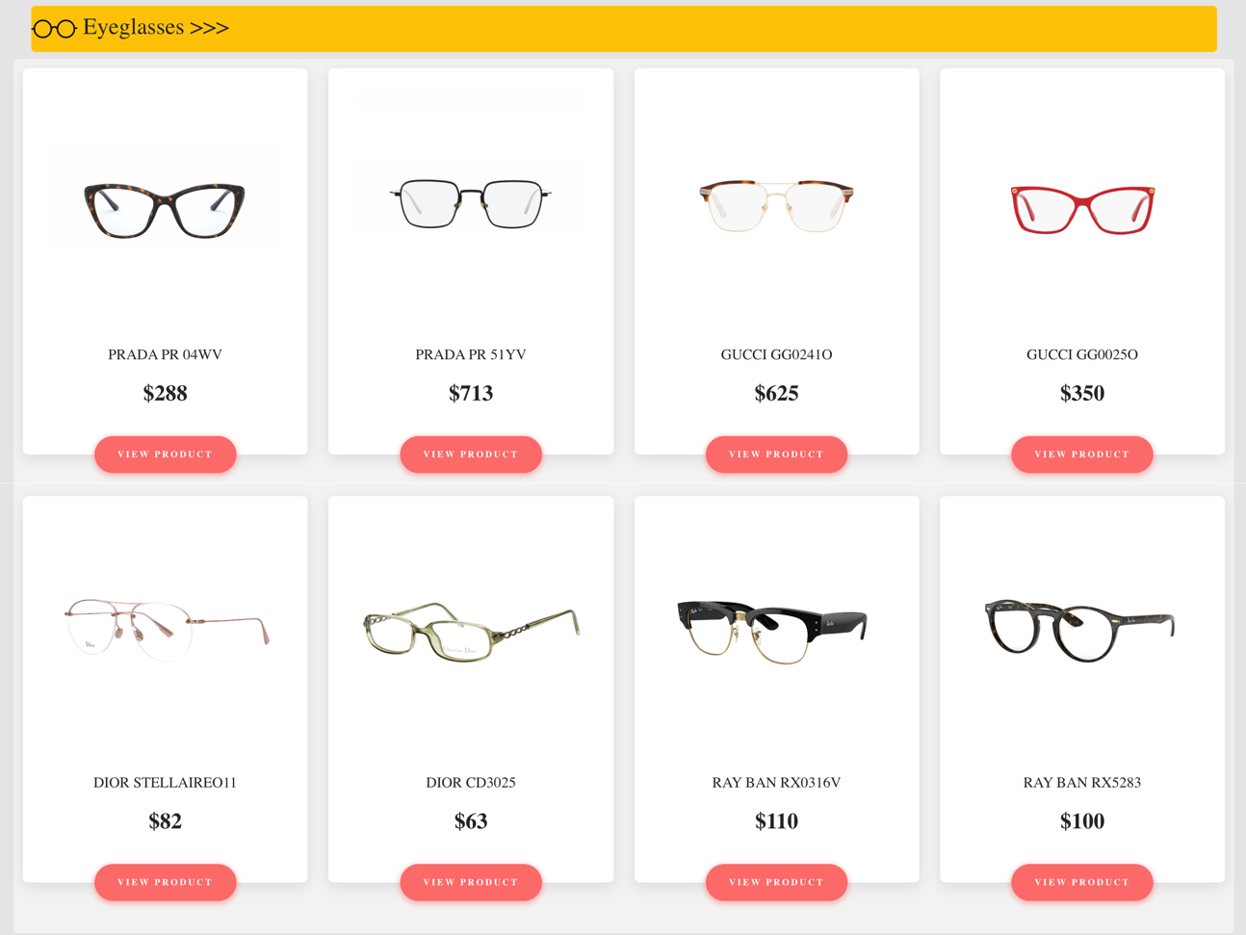

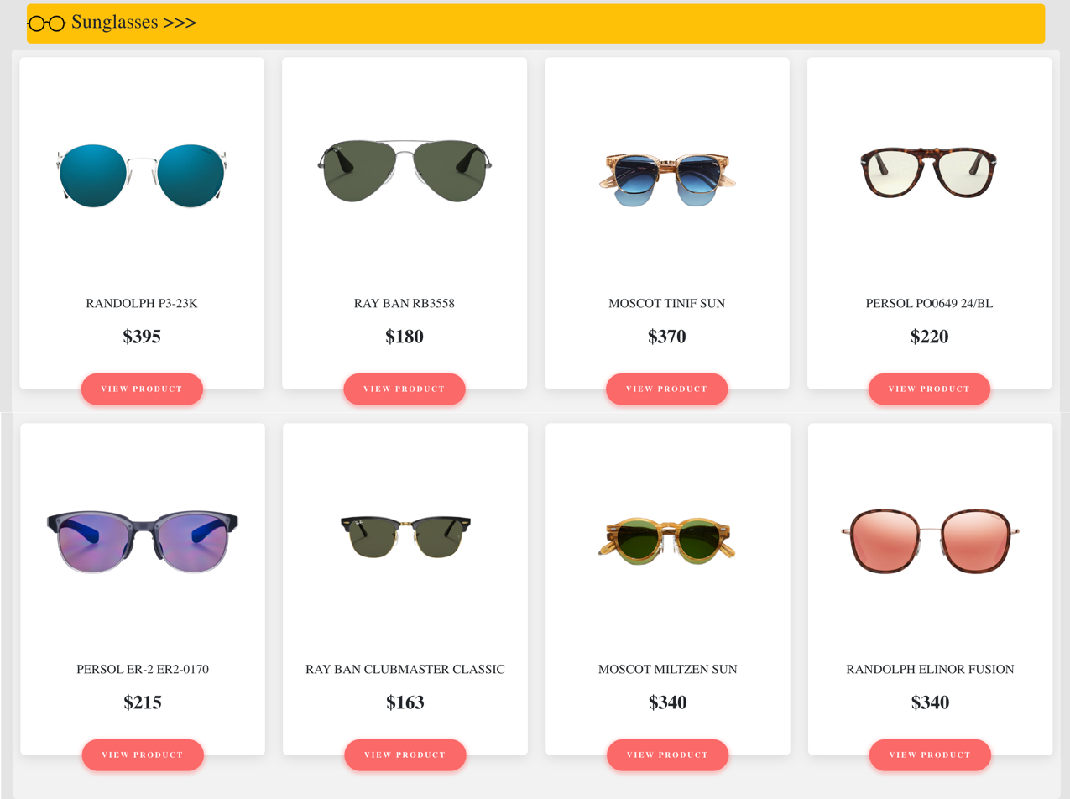

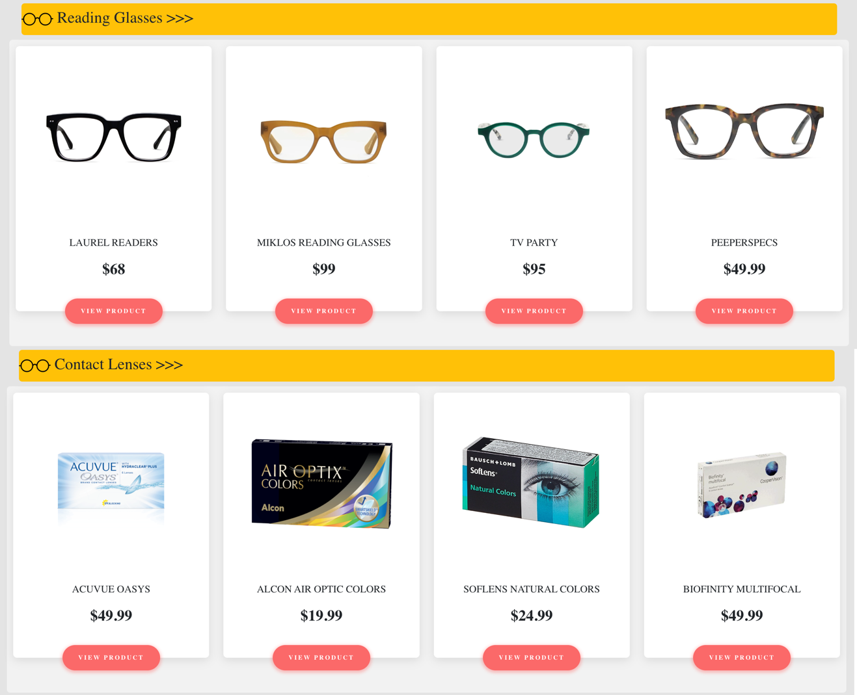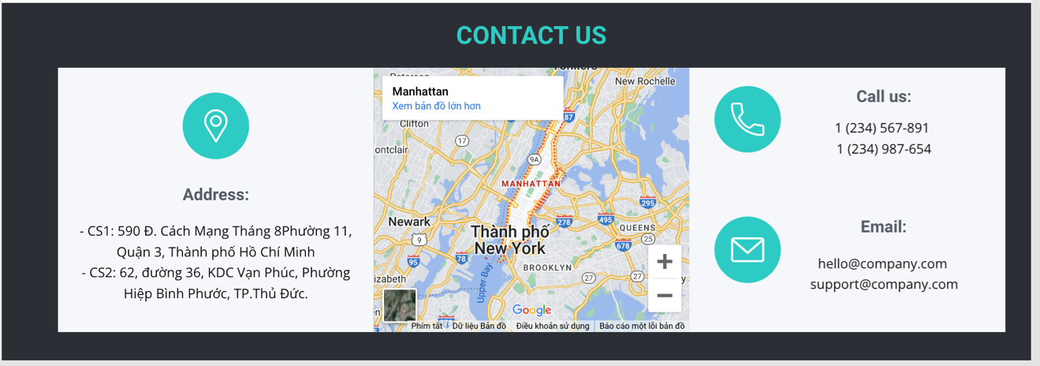

### Sign in

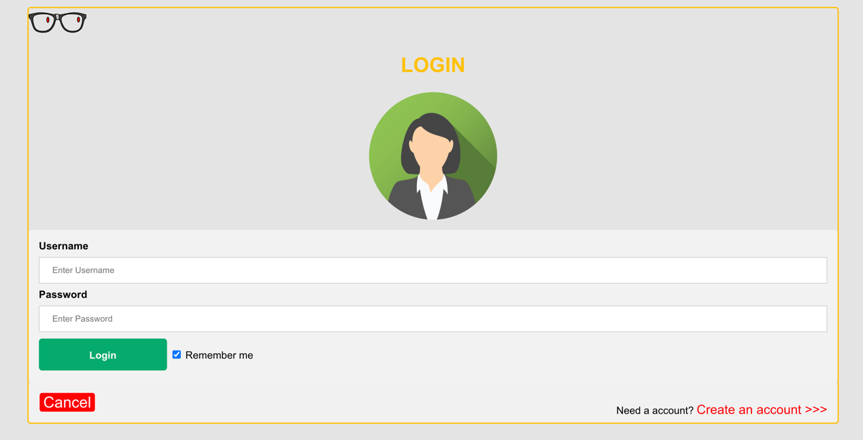

### Sign up

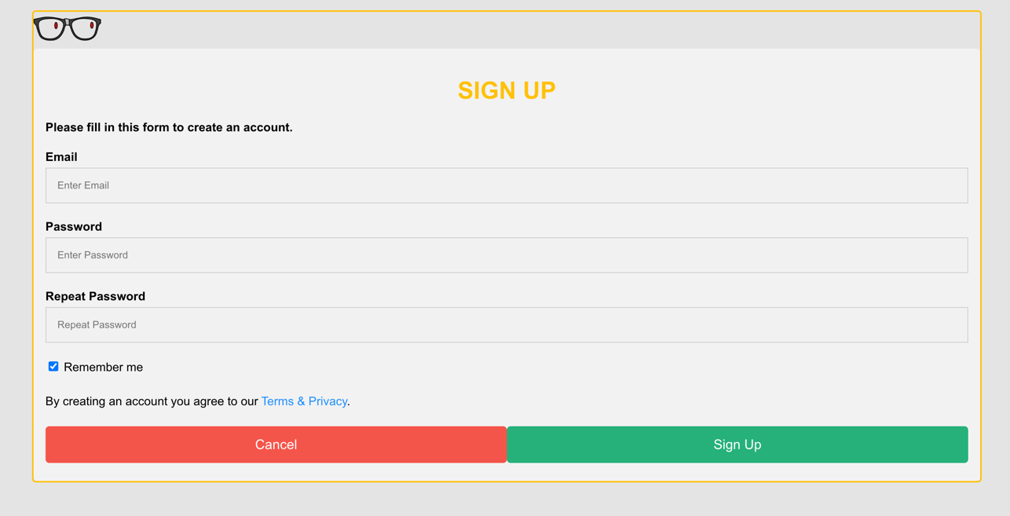

### Product Category/Search Page

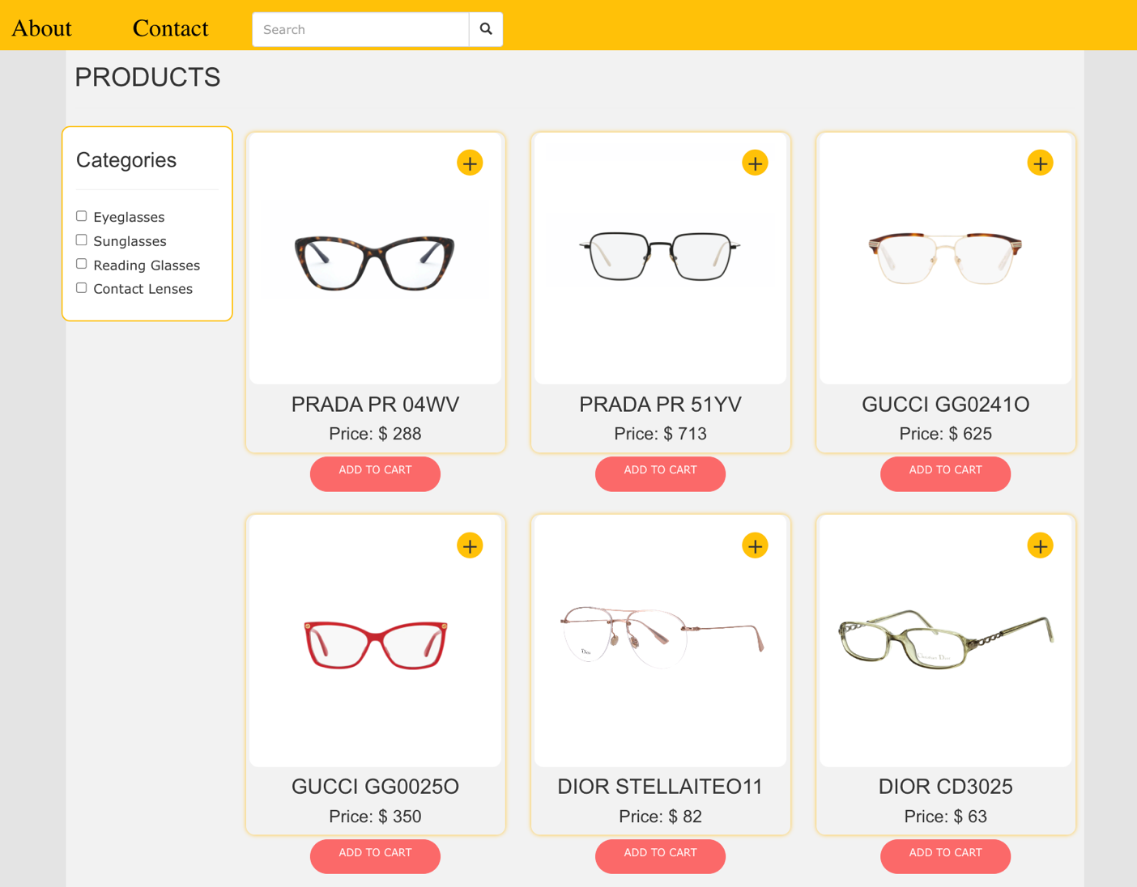

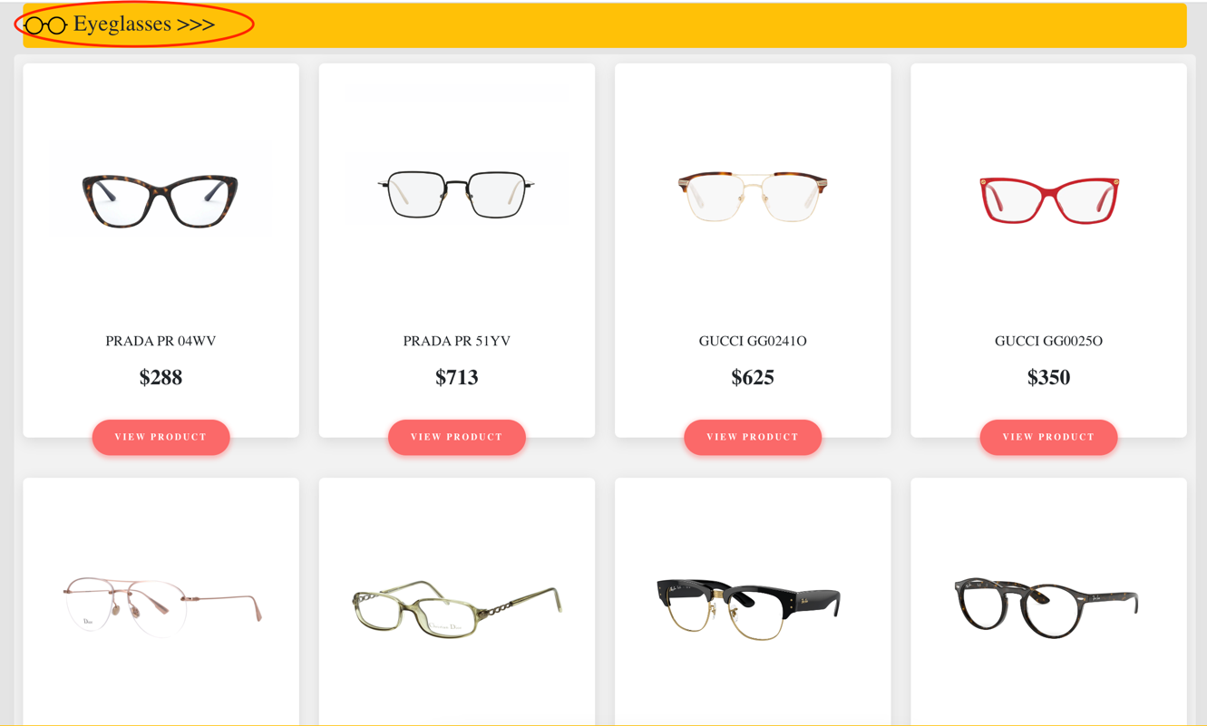

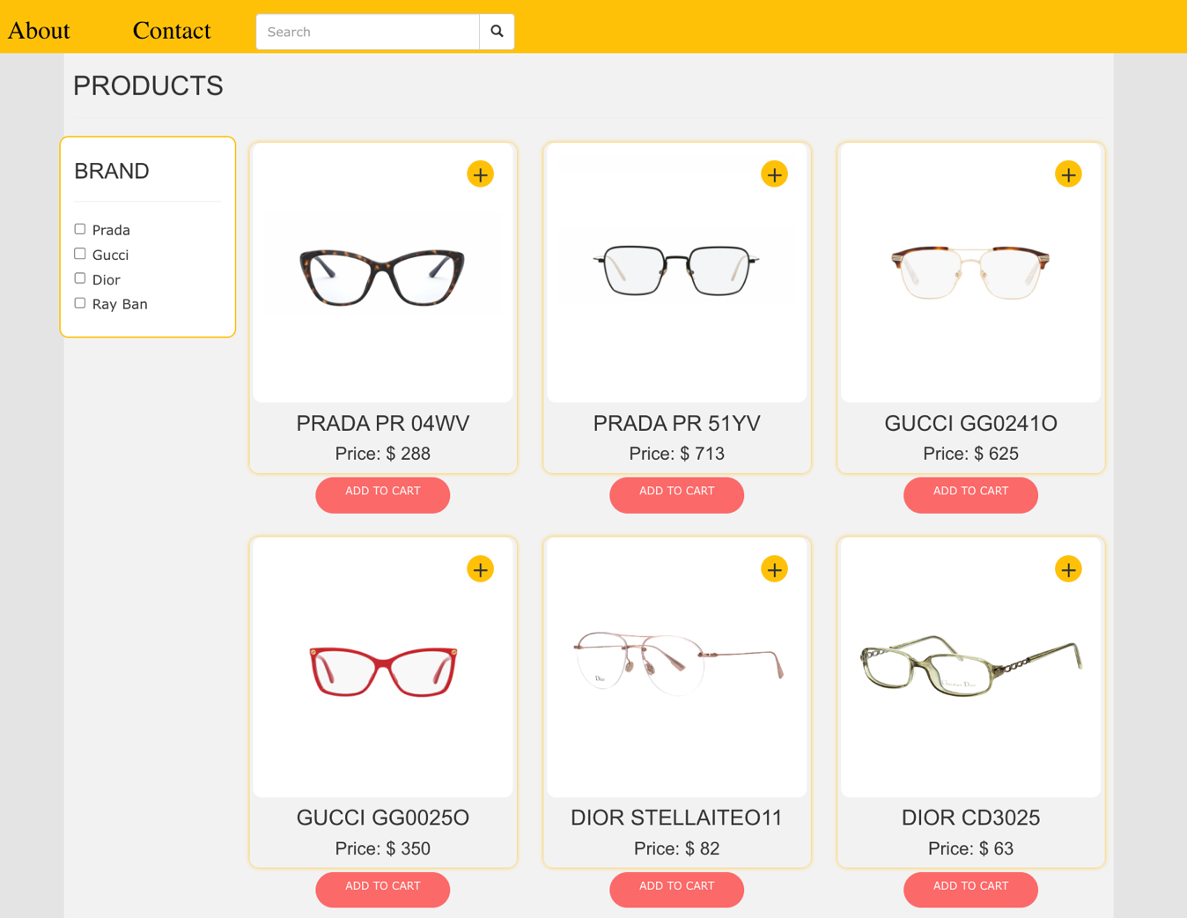

### Product Comparison

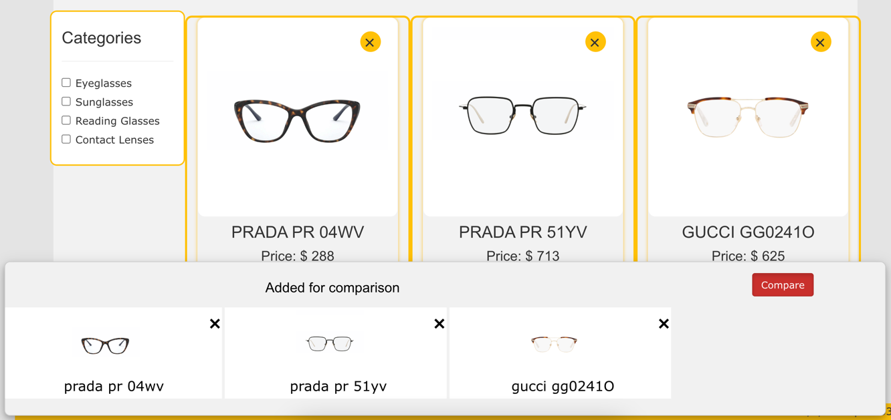

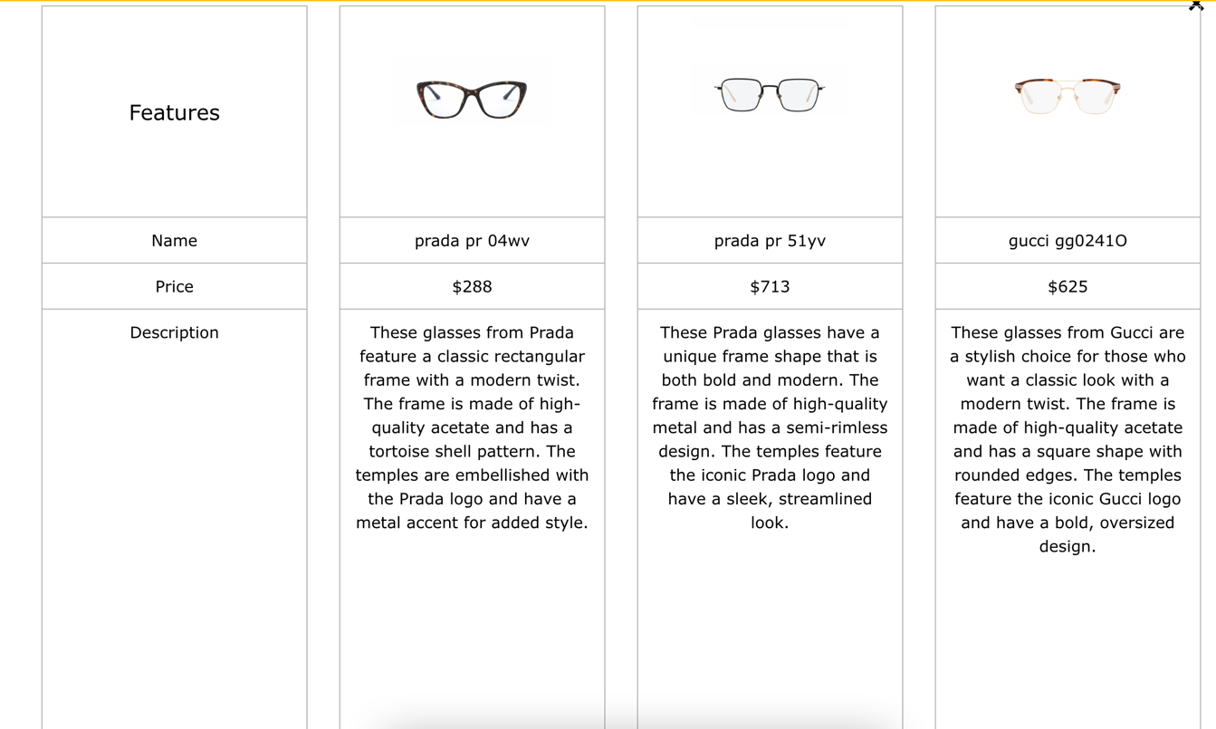

### Product Detail

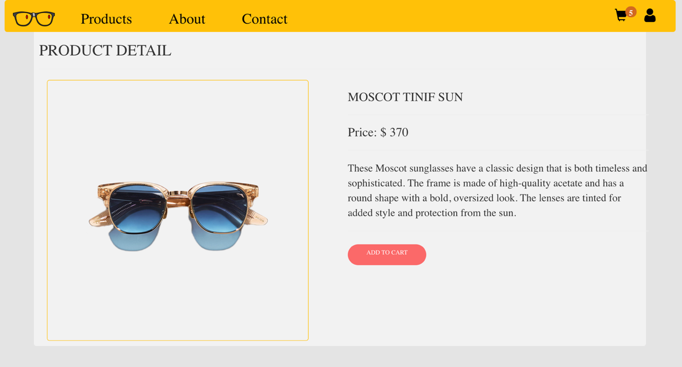

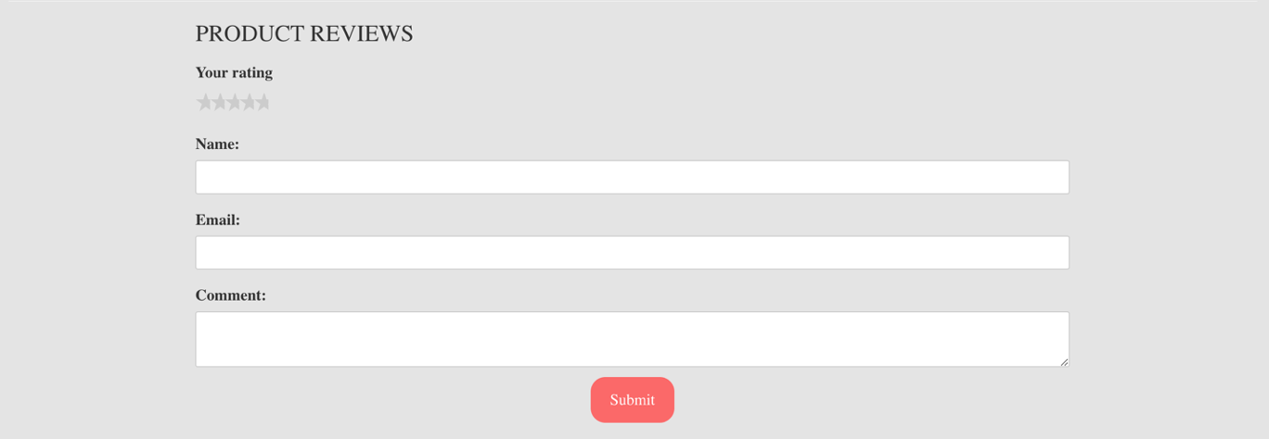

### Cart Dropdown

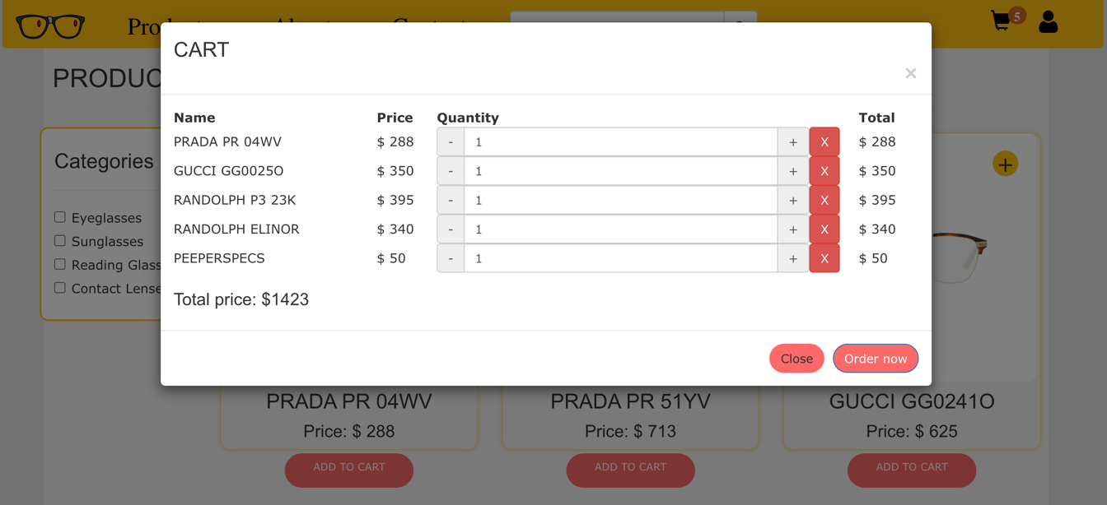

### Check out

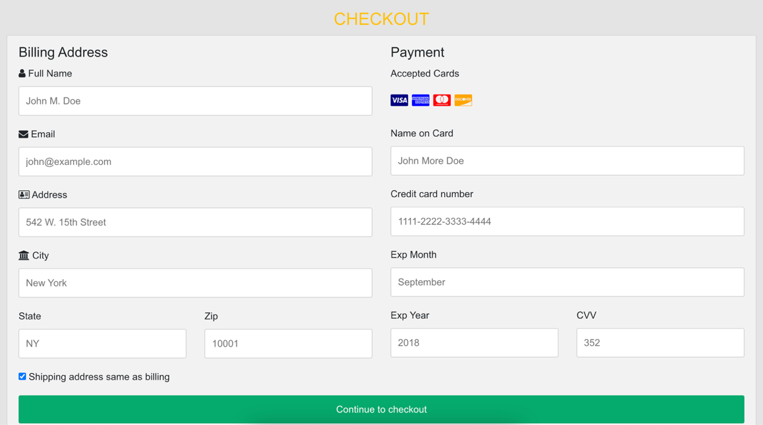

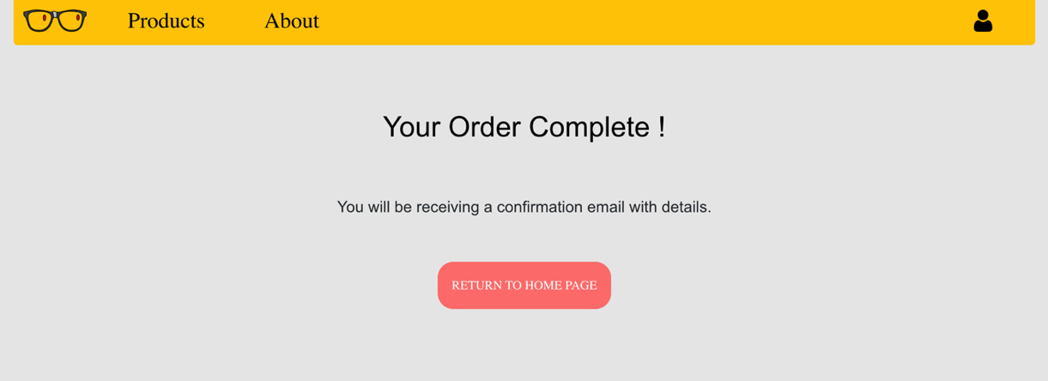

### Contact

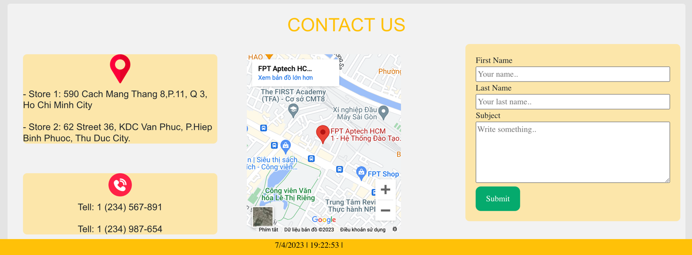

### About



## Task Sheet

|  |  |  |  |  |  |  |
| --- | --- | --- | --- | --- | --- | --- |
| **Project Ref No.** | **Project Title – Ask Me Mobile** | **Activity Plan Prepared by** | **Date of preparation of Activity Plan** | | | |
| **Task** | **Actual Start Date** | **Actual Days** | **Teammate Names** | **Status** |
| Brainstorming ideas for layouts and Project Object | | Binh, Phuc, Bao,  Chuong | 11/03/2023 | 1 days | Binh, Phuc, Bao,  Chuong | Completed |
| Draw site maps and architecture design | | Binh, Phuc, Bao | 14/03/2023 | 1 days | Binh, Phuc, Bao | Completed |
| Wire framing general page layout | | Binh | 14/03/2023 | 3 days | Binh | Completed |
| Collect static assets (pictures, documentation,…) | | Chuong,  Bao | 16/03/2023 | 5 days | Chuong, Bao | Completed |
| Design & Build Homepage | | Binh | 23/03/2023 | 8 days | Binh | Completed |
| Design & Build Sign in | | Phuc | 25/03/2023 | 5 days | Phuc | Completed |
| Design & Build Sign up | | Phuc | 25/03/2023 | 5 days | Phuc | Completed |
| Design & Build Product Category/Search Page | | Binh | 25/03/2023 | 5 days | Binh | Completed |
| Design & Build Product Detail | | Chuong | 23/03/2023 | 4 days | Chuong | Completed |
| Design & Build Cart Dropdown | | Chuong | 25/03/2023 | 2 days | Chuong | Completed |
| Design & Build Check out | | Phuc | 28/03/2023 | 5 days | Phuc | Completed |
| Design & Build Contact | | Bao | 23/03/2023 | 5 days | Bao | Completed |
| Design & Build About | | Phuc | 23/03/2023 | 3 days | Phuc | Completed |
| Product Comparison | | Binh | 28/03/2023 | 1 days | Binh | Completed |
| Write Project Report | | Binh | 04/04/2023 | 1 days | Binh | Completed |

## Testing document

|  |  |  |  |  |
| --- | --- | --- | --- | --- |
| **Sr.No** | **Features Tested** | | | **Remarks** |
| 1 | Are all the users able to view the images and links? | | | OK |
| 2 | Have all the views, modules and controllers been | |  | OK |
| properly integrated and is the site function as a single | | |
| page application? | |  |
| 3 | Are the GUI content devoid of spelling mistakes? | | | OK |
| 4 | Is the application user-friendly? | | | OK |
| 5 | Is the Website launching correctly in all popular | |  | OK |
| browsers? |  |  |
| 6 | Are all the forms validated with proper criteria? | | | OK |
| 7 | Do all text links lead to the appropriate website? | | | OK |
| 8 | Do all image links lead to the appropriate website? | | | OK |
| 9 | Are all the images and links clearly visible on the page? | | | OK |
| 10 | Does the Web page work properly in all the tested | |  | OK |
| browsers? |  |  |
| 11 | Does the Web page take too long to be loaded fully? | | | OK |
| 12 | Is the navigation sequences correct through all the Web | | | OK |
| pages on the site? | |  |
| 13 | Is the JavaScript code working as expected in all click | | | OK |

## Final checklist

|  |  |  |  |  |
| --- | --- | --- | --- | --- |
| **Sr.No** | **Features Tested** | | | **Remarks** |
| 1 | Are all the users able to view the images and links? | | | OK |
| 2 | Have all the views, modules and controllers been | |  | OK |
| properly integrated and is the site function as a single | | |
| page application? | |  |
| 3 | Are the GUI content devoid of spelling mistakes? | | | OK |
| 4 | Is the application user-friendly? | | | OK |
| 5 | Is the Website launching correctly in all popular | |  | OK |
| browsers? |  |  |
| 6 | Are all the forms validated with proper criteria? | | | OK |
| 7 | Do all text links lead to the appropriate website? | | | OK |
| 8 | Do all image links lead to the appropriate website? | | | OK |
| 9 | Are all the images and links clearly visible on the page? | | | OK |
| 10 | Does the Web page work properly in all the tested | |  | OK |
| browsers? |  |  |
| 11 | Does the Web page take too long to be loaded fully? | | | OK |
| 12 | Is the navigation sequences correct through all the Web | | | OK |
| pages on the site? | |  |
| 13 | Is the JavaScript code working as expected in all click | | | OK |